**Creation Of Tables**



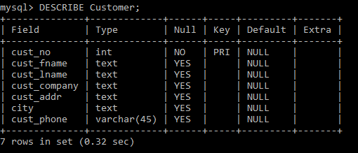

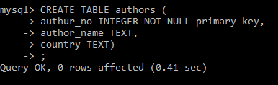

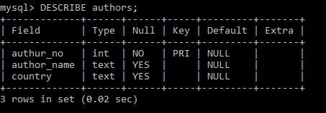

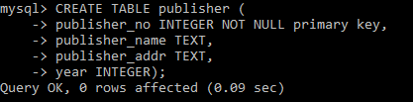

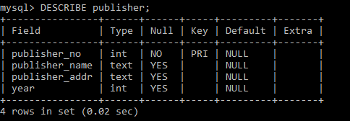

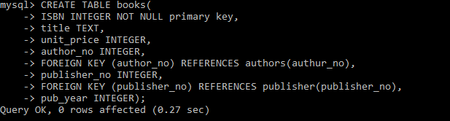

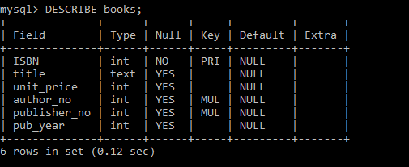

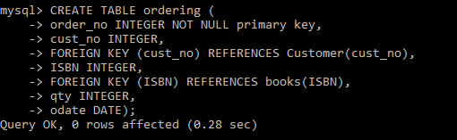

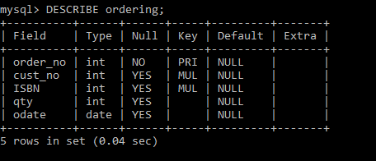

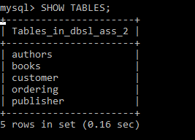

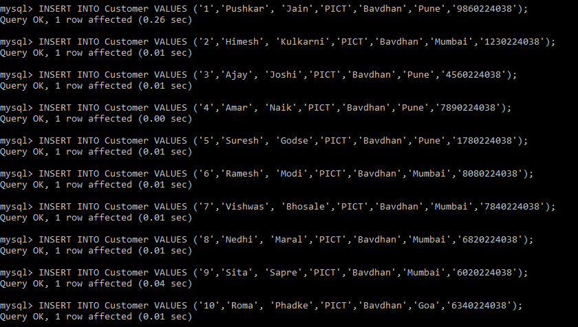

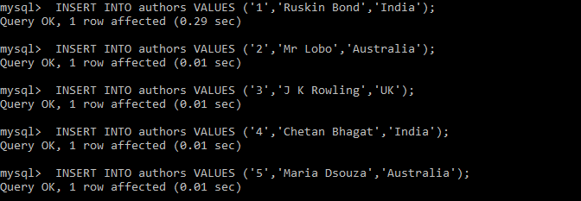

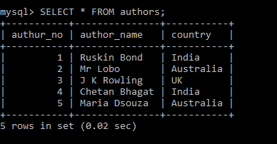

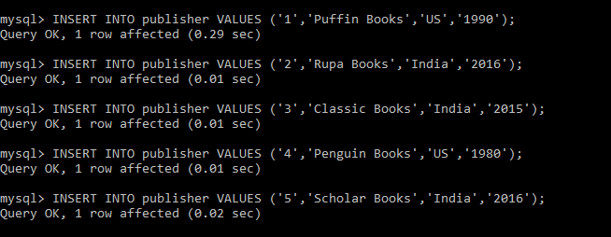

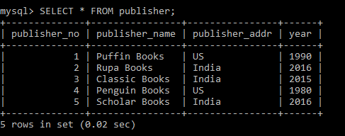

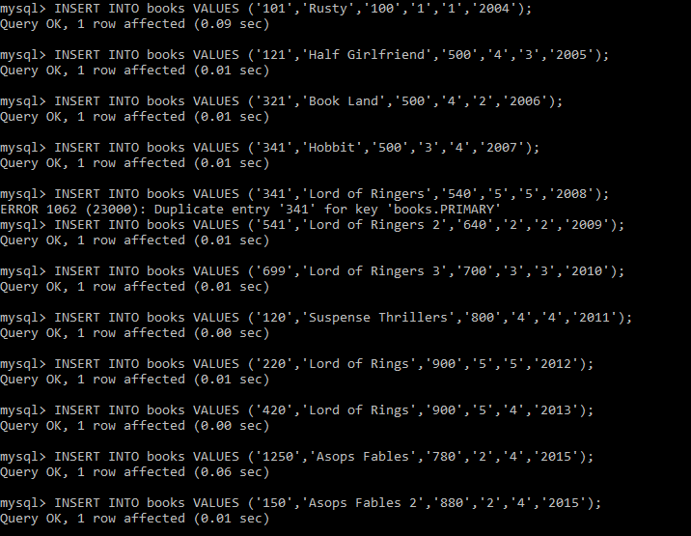

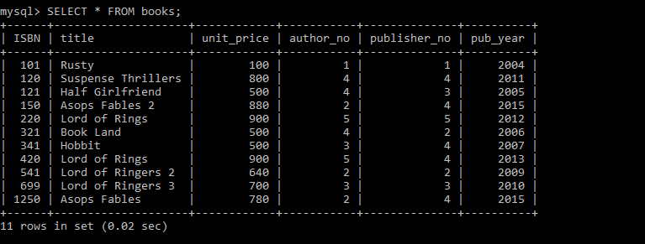

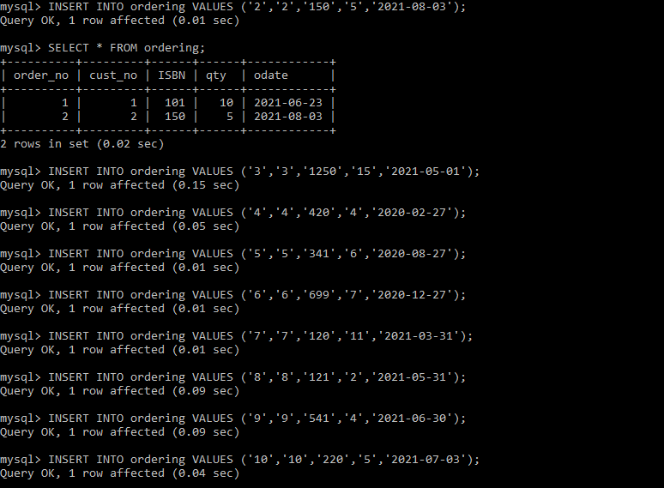

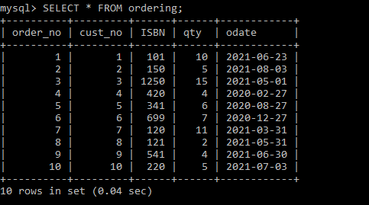

**Queries**

Query 1 – Insert at least 10 records in customer table and insert other tables accordingly.



Query 2 – Display all customer details with city pune and mumbai and customer first name starting with 'p' or 'h'.

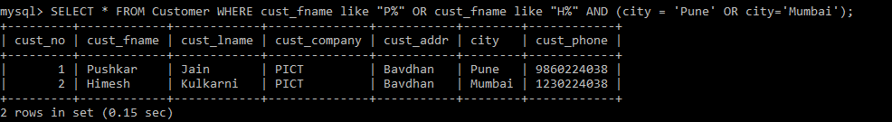

Query 3 – lists the number of different customer cities.(use of distinct)

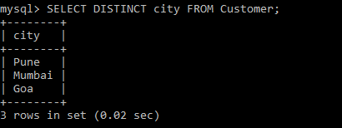

Query 4 – Give 5% increase in price of the books with publishing year 2015. ( use of update)

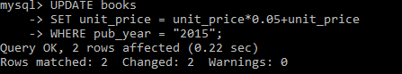

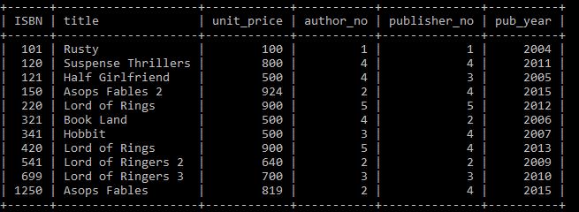

Query 5 – Delete customer details living in pune.



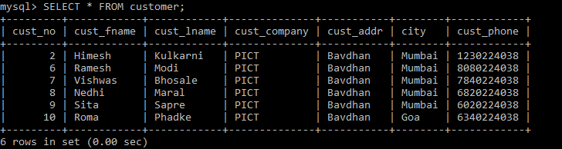

Query 6 – Find the names of authors living in India or Australia (use of UNION)

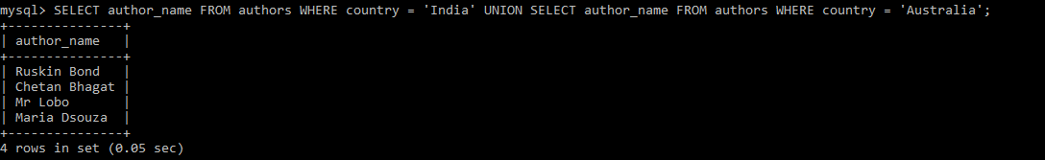

Query 7 – Find the publishers who are established in year 2015 as well as in 2016 (use of INTERSECT)

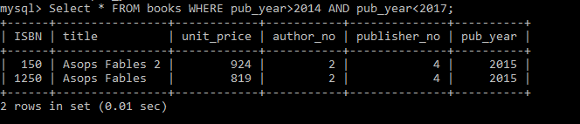

Query 8 – Find the book having maximum price and find titles of book having price between 300 and 400.(use of max and between)

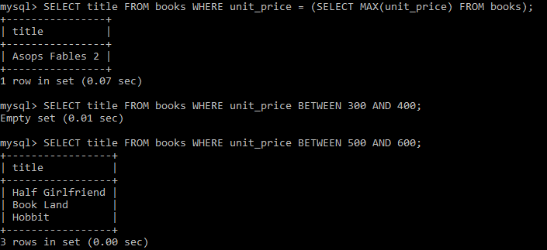

Query 9 – Display all titles of books with price and published year in decreasing order of publishing year.

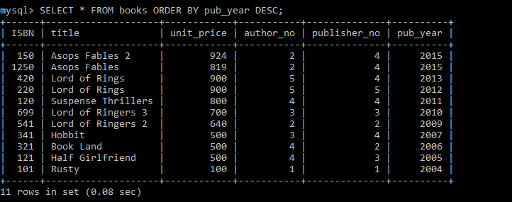

Query 10 – Display title,author_no and publisher_no of all books published in 2000,2004,2006. (use of IN)

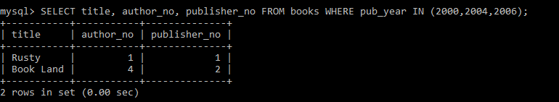

Query 11 – Create view showing the books and authors details. (COMPLEX VIEW)

